1. **Agenda**:
   1. We will discuss some annotations which we can use with Mockito for clean Test code.
   2. We will discuss the following annotations:  
      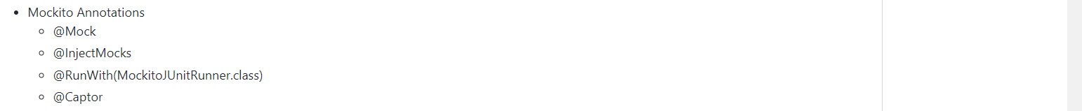
2. **Link for this step**:  
   <https://github.com/in28minutes/MockitoTutorialForBeginners/blob/master/Step10.md>
3. If you want to user annotations from Mockito, then you need to run the test class with a particular Mockito Runner.
   1. **@RunWith**(MockitoJUnitRunner.class)
4. 
5. A picture containing text

   Description automatically generated**@InjectMock** Creates an object for the actual class without calling constructor and settings all its dependencies through say reflection. So no constructor call.
6. The important thing about Mockito is that it makes mocking easy & the important thing about Mockito annotations (@Mock, @InjectMock, @Captor) is that it makes mocking much easier.